Rio das Pedras (RdP) is the third largest informal community in Rio de Janeiro, Brazil. Home to approximately 63,500 residents. Residents of RdP face unique health challenges. Aggravated by seasonal flooding, hectic vehicle traffic, continuous construction, soil instability, and improvised waste disposal facilities, the limited access to municipal services and transportation likely predispose residents to injury and poor health. However, limited data exists that can accurately characterize the health of residents of RdP, and fewer data that can point out areas of intervention that have high return on investment (ROI) potential. As a result, there is little evidence to guide infrastructure investment or other initiatives to protect the health of residents. To fill this gap, the [Built Environment and Health Research Group at Columbia University (BEH)](http://beh.columbia.edu/) is undertaking a [Community Needs Assessment (Community Health Diagnosis) for the Rio das Pedras area.](http://beh.columbia.edu/2014/07/25/rio-das-pedras-community-needs-assessment/)

Led by [Dr. Gina Lovasi](http://www.mailman.columbia.edu/our-faculty/profile?uni=gl2225) and sponsored by Medtronic Philanthropy, our research project has brought together an interdisciplinary group of global experts to perform an initial community needs assessment in Rio das Pedras, Rio de Janeiro, Brazil. In addition to creating a community health profile for Rio das Pedras, this project will inform future large scale data collection on health, mobility, and the microbiome in informal communities. Informal communities house more than one billion people globally.

**Rio Das Pedras, Rio de Janiero, Brazil**

[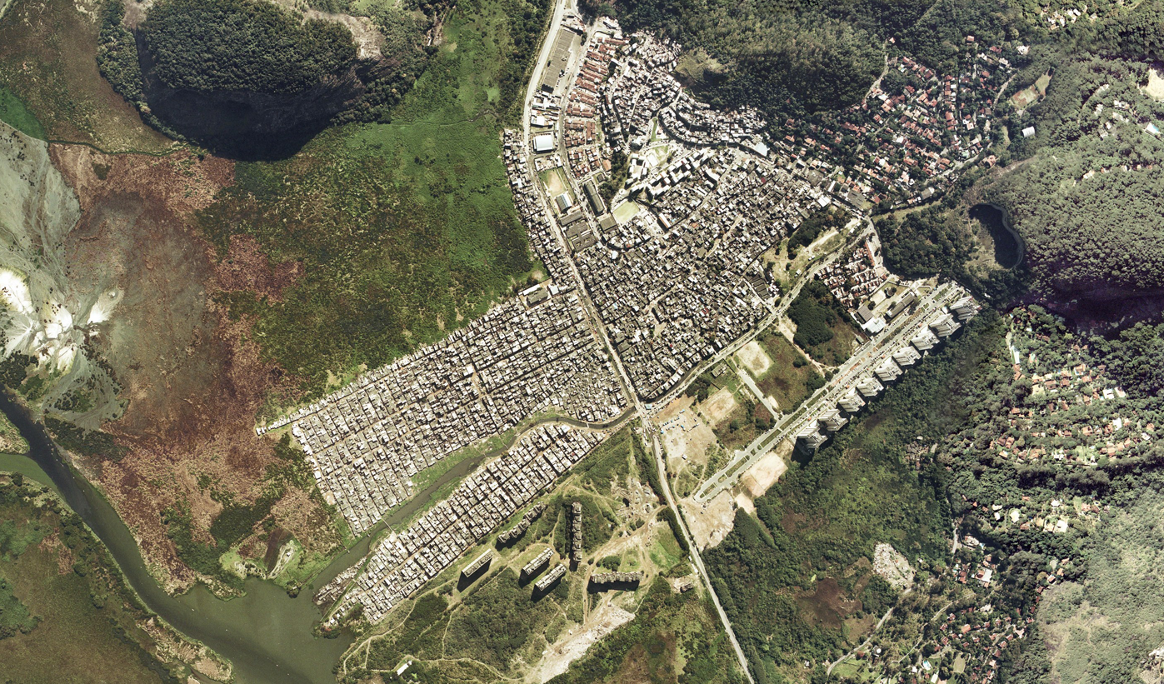](https://github.com/nygeog/beh_public/blob/master/rio/tasks/201504_fulcrum_blogpost/img/brasil_gov_rdp_aerial.png)

Source: Instituto Brasileiro de Geografia e Estatística

**Discovering Fulcrum**

The BEH Group's research often requires assembling pre-existing geographic data while also collecting observational data on neighborhood characteristics and conditions as needed. [Dr. Andrew Rundle](http://www.mailman.columbia.edu/our-faculty/profile?uni=agr3), [Dr. Michael Bader](http://mikebader.net/), PhD Candidate [Steve Mooney](https://scholar.google.com/citations?user=Sd7opuwAAAAJ&hl=en) and others in the BEH Research Group developed a [Virtual Street Audit Tool using Google Street View named CANVAS](http://beh.columbia.edu/2015/01/05/new-research-using-google-street-view-to-conduct-neighborhood-virtual-audits/) for collecting observational data on neighborhood characteristics and conditions such as physical disorder. Unfortunately, Google Street View was not available for most streets and alleyways in RdP.

The initial phases of the project involved planning out participant recruitment and data collection via interviews, water and saliva samples, and GPS logging, to be followed by linkage to GIS data on the environment, While we were considering ways to scout secondary data, it quickly became clear that we would need to collect data and photos in the field to support our understanding and documentation of the built environment. [Senior GIS Analyst Daniel M. Sheehan](http://nygeog.github.io/) came across a [CartoDB blogpost about using Fulcrum](http://docs.cartodb.com/tutorials/data_collection_fulcrum.html) and realized that [Fulcrum](http://fulcrumapp.com/) might be a great option for collecting spatial data in the field. This tool enabled the field team to systematically collect neighborhood conditions data in-person in real-time with Fulcrum via mobile phones. The BEH group developed a custom form with the Fulcrum App to help collect that data, and were able to deploy data collections without clipboards, and without dependence on local wifi or an international data plan.

We did our first round of pilot data collection in March 2015. And the field team is back in the field again this May. We were able to create a new modified Fulcrum App based on the March experience, and also add our own [Map Layers](http://fulcrumapp.com/help/adding-layers/).

[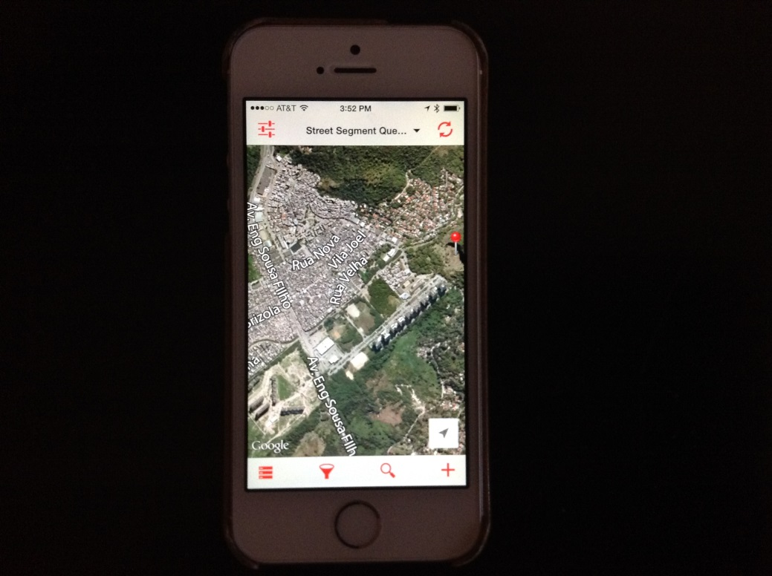](https://github.com/nygeog/beh_public/blob/master/rio/tasks/201504_fulcrum_blogpost/img/phone.jpg)

**Notes from the field**

Project Coordinator, Garazi Zulaika:

Fulcrum hugely facilitated data collection in the field. The Fulcrum's fast synchronization allowed us to communicate in real time and field test our data collection questions with collaborators in different countries. Fulcrum’s ability to store multiple entry points and photos allowed us to collect data throughout the entire day without accessing internet in the field. Another tool that was extremely useful was the Fulcrum's ability to pan away from the location set by the device’s GPS. Given our data collection is ongoing in a large informal community with informal construction methods that lead to building canyons and poor satellite reception, the ability to change the location of the device by a block or a street hugely improved the accuracy of the data being collected. We found that certain mobile devices had extremely accurate GPS locators while older devices had a harder time correctly identifying the user’s location. The user friendly platform allowed our research team to tailor the questions to fit our needs, incorporating context specific questions, modifying the answer categories, adding and deleting items, and going back and editing the responses even after the pilot testing had been completed. The Fulcrum App did not force us to answer questions in order which allowed us to mark things as we came across them while moving through the informal community. Fulcrum’s flexibility was extremely valuable and allowed us to collect data extremely efficiently and quickly. I look forward to using it again in the field!

We hope to provide an updated blogpost and follow-up to our 2nd field data collection effort.

**Geotagged images from the field**

[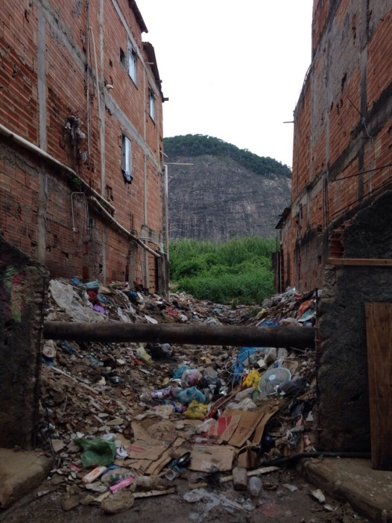](https://github.com/nygeog/beh_public/blob/master/rio/tasks/201504_fulcrum_blogpost/img/pipe.jpg)

Sewer pipes in RdP geotagged photo via Fulcrum.

[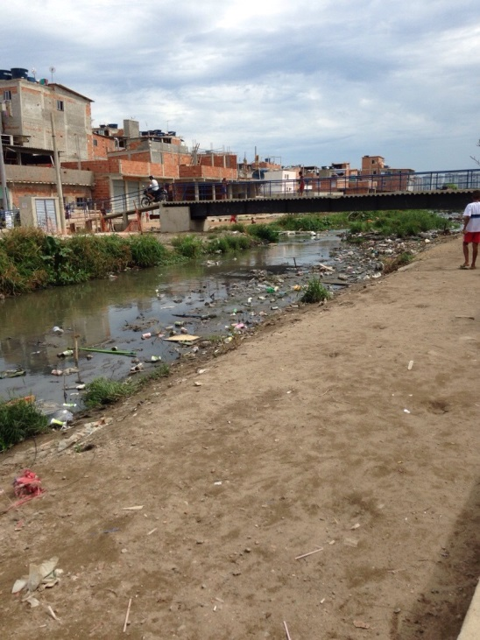](https://github.com/nygeog/beh_public/blob/master/rio/tasks/201504_fulcrum_blogpost/img/canal.jpg)

Avenida canal in RdP geotagged photo via Fulcrum.